Software Design Document (SDD)

Lab Assignment 02: TIM (Timers)

Module | TIM Driver
Version | 1.1
Team | Sebastian Lizalde Herrera, Michelle Urbina Carlos, Melanie Picen Hernández
Date | 26/04/2026
Institution | CETYS Universidad

- Introduction

  - Purpose

This document describes the design and architecture of the TIM (Timer) driver module for the STM32F411RE microcontroller, based on the requirements defined in the Software Requirements Specification (SRS-TIM_Driver v1.1). It provides details on data structures, register mappings, algorithms, and control flow to guide implementation and testing.

  - Scope

The TIM driver is a low-level software component for the STM32F411RE embedded system. It abstracts the TIM hardware registers and provides a clean API for higher-level modules requiring precise timing, delay generation, and PWM signal output. The driver supports TIM1 through TIM5 and TIM9 through TIM11.

  - Definitions and Acronyms

Term | Definition
TIM | Timer peripheral in STM32 microcontrollers — a hardware counter driven by the system clock that can generate periodic events, PWM signals, and input capture.
PSC | Prescaler Register — divides the input clock to produce the timer tick frequency. f_tick = f_clk / (PSC + 1).
ARR | Auto-Reload Register — defines the timer period. The counter counts from 0 to ARR, then resets and sets the UIF flag.
CNT | Counter register — holds the current count value of the timer.
CCR | Capture/Compare Register — holds the compare threshold for a channel. In PWM mode, determines the duty cycle.
CCMR | Capture/Compare Mode Register — configures the operating mode (PWM, toggle, etc.) for each capture/compare channel.
CCER | Capture/Compare Enable Register — enables or disables each channel output.
UIF | Update Interrupt Flag — bit 0 of TIMx_SR. Set by hardware when the counter reaches ARR and overflows.
PWM | Pulse Width Modulation — a signal with a fixed frequency and variable duty cycle, generated by comparing CNT with CCR.
RCC | Reset and Clock Control — peripheral responsible for enabling clocks to TIM peripherals.
APB1 | Advanced Peripheral Bus 1 — bus to which TIM2–TIM5 are connected. Max frequency 50 MHz on the STM32F411RE.
APB2 | Advanced Peripheral Bus 2 — bus to which TIM1, TIM9, TIM10, and TIM11 are connected. Max frequency 100 MHz.
SRS | Software Requirements Specification — document defining functional and non-functional requirements.
SDD | Software Design Document — this document.
FR | Functional Requirement — specifies a behavior the system must implement.

  - Requirements

Req. ID | Function | Requirement Statement
FR-1 | tim_init() | The system shall configure all TIM peripherals to a default state.
FR-2 | tim_initTimer() | The system shall enable clocking and configure the specified timer.
FR-3 | tim_setTimerMs() | The system shall calculate PSC and ARR values to achieve the requested interval.
FR-4 | tim_setTimerFreq() | The system shall calculate PSC and ARR values to achieve the requested frequency.
FR-5 | tim_enableTimer() | The system shall start counting and generate update events.
FR-6 | tim_disableTimer() | The system shall stop the specified timer from counting.
FR-7 | tim_waitTimer() | The system shall block execution until the timer reaches its overflow/update event.
FR-8 | tim_setTimerCompareChannelValue() | The system shall trigger a compare event when the counter reaches the threshold.
FR-9 | tim_setTimerCompareMode() | The system shall allow configuration of compare modes using register settings.
FR-10 | tim_enableTimerCompareChannel() | The system shall activate the specified channel to generate compare events.
FR-11 | tim_disableTimerCompareChannel() | The system shall deactivate the specified channel, preventing compare events.

- System Architecture

  - High-Level Design

The TIM driver follows the same layered software architecture as the GPIO driver, separating application logic from hardware register access.

Layer | Description
Application Layer | Higher-level modules (Timer module, PWM module) that call TIM driver public API functions to configure timers and channels without direct register access.
TIM Driver Layer | Implements all public API functions declared in TIM_Driver.h. Validates inputs, calculates PSC/ARR values, and performs register read-modify-write operations via the tim_peripherals[] lookup table.
Hardware Layer | Actual STM32F411RE TIM peripheral registers (CR1, SR, PSC, ARR, CNT, CCMR1/2, CCER, CCR1–4) and RCC APB1ENR/APB2ENR clock enable registers, mapped at their hardware addresses.

  - Module Interfaces

The TIM driver exposes its functionality exclusively through TIM_Driver.h:
- Public API: All 11 user-callable functions declared in TIM_Driver.h (tim_init through tim_disableTimerCompareChannel).
- Internal implementation: Function bodies and static data structures (tim_peripherals[], tim_max_channels[]) are defined in TIM_Driver.c and not visible externally.
- Internal helper functions: tim_enableClock(), tim_writeCCR(), and tim_writeOCMode() are declared static and used only within TIM_Driver.c.
- Dependencies: TIM_Driver.h includes GPIO_stm32f4.h to reuse the PERIPH_BASE, AHB1PERIPH_BASE, and RCC_BASE definitions. No HAL, CMSIS, or RTOS dependency is introduced.
- Hardware dependencies: STM32F411RE TIM peripheral registers on APB1 (TIM2–TIM5) and APB2 (TIM1, TIM9–TIM11) buses, and RCC APB1ENR/APB2ENR at offset 0x40/0x44 from RCC_BASE.

- Detailed Design

  - Class Diagram

The figure below shows the static structure of the TIM driver: the two register-map structs, the four enumerations, and the public API class with all eleven functions.

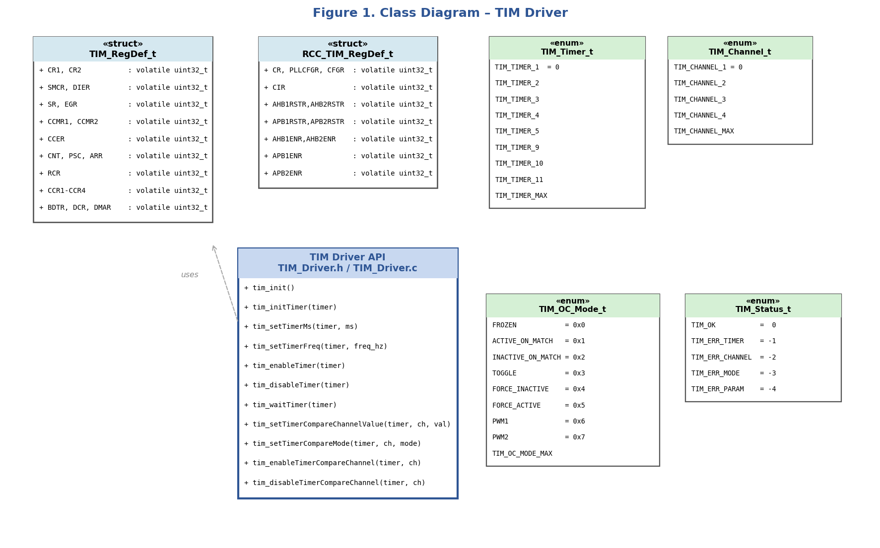
Figure 1. Class Diagram — TIM Driver

  - Module Behavior

The following diagrams describe the behavioral design of the key public functions. Each function is covered by a sequence diagram showing actor interactions and an activity diagram showing internal logic flow.

tim_init — Global Initialization (FR-1)

The function iterates over all eight supported timer identifiers (TIM_TIMER_1 through TIM_TIMER_11). For each timer it calls the internal helper tim_enableClock() to set the appropriate APB1ENR or APB2ENR bit in RCC, then resets CR1, PSC, ARR, CNT, CCER, and SR to known default values. No return value is provided because this function is intended as a system-level initializer called unconditionally at startup.

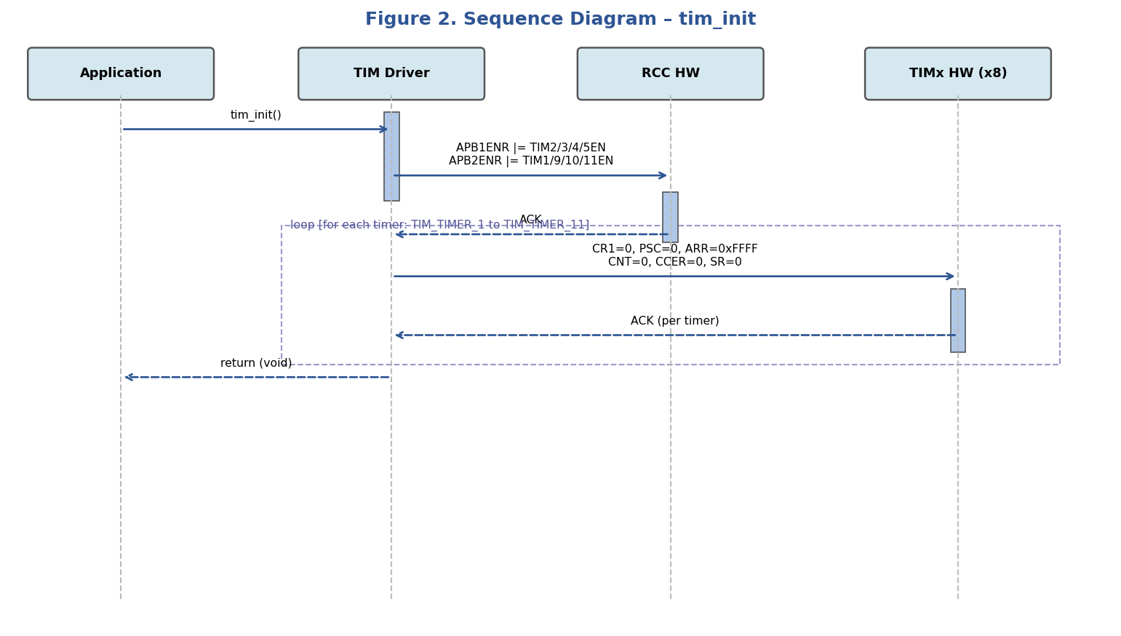
Figure 2. Sequence Diagram — tim_init

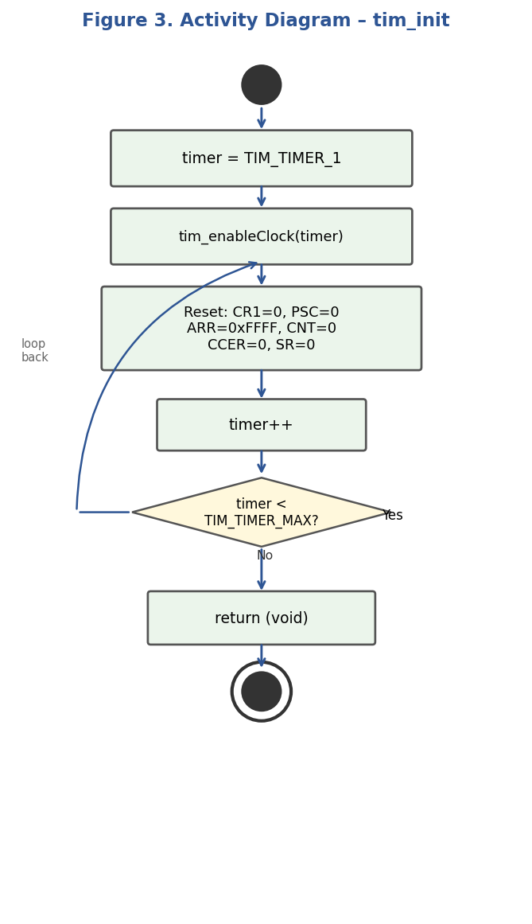
Figure 3. Activity Diagram — tim_init

tim_setTimerMs — Interval Configuration (FR-3)

The function validates the timer identifier and rejects a zero interval (TIM_ERR_PARAM). For valid inputs it derives PSC and ARR from the system clock and the requested millisecond interval using the formula: counts = (f_clk / 1000) × ms; PSC = counts / 65536; ARR = counts / (PSC + 1) − 1. Dividing counts by 65536 ensures ARR fits within a 16-bit register for all 16-bit timers (TIM1, TIM3, TIM4, TIM9–TIM11). TIM2 and TIM5 have 32-bit ARR and also work correctly. The UIF flag is cleared after writing PSC and ARR to prevent a spurious update event on the first cycle.

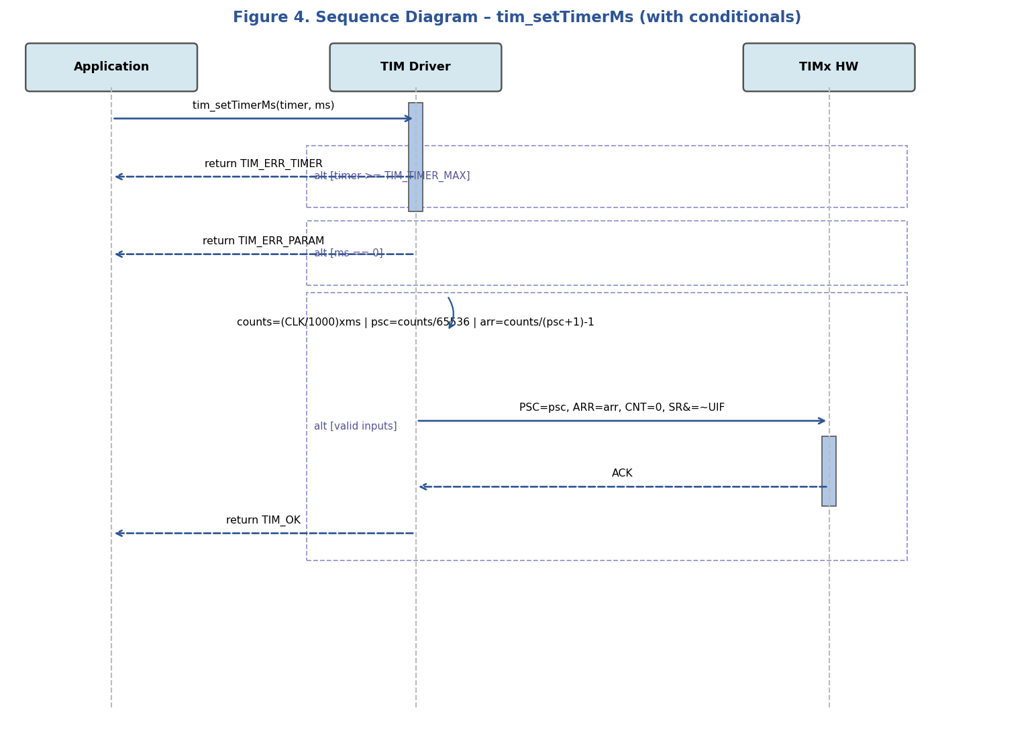
Figure 4. Sequence Diagram — tim_setTimerMs (with conditionals)

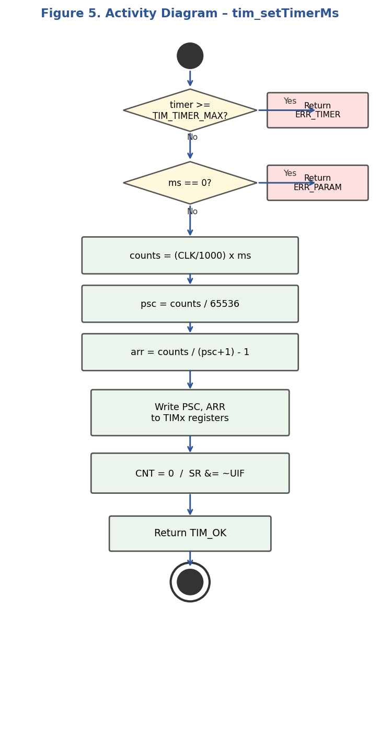
Figure 5. Activity Diagram — tim_setTimerMs

tim_waitTimer — Blocking Delay (FR-7)

After validating the timer, the function enters a busy-wait loop polling the UIF bit (bit 0) of TIMx_SR until it is set by hardware on counter overflow. The flag is then cleared by writing 0 to the UIF bit (rc_w0 access type per RM0383 §13.4.5). This is a blocking, polling implementation — caller must ensure the timer is running (tim_enableTimer called) before invoking this function, otherwise it will loop indefinitely.

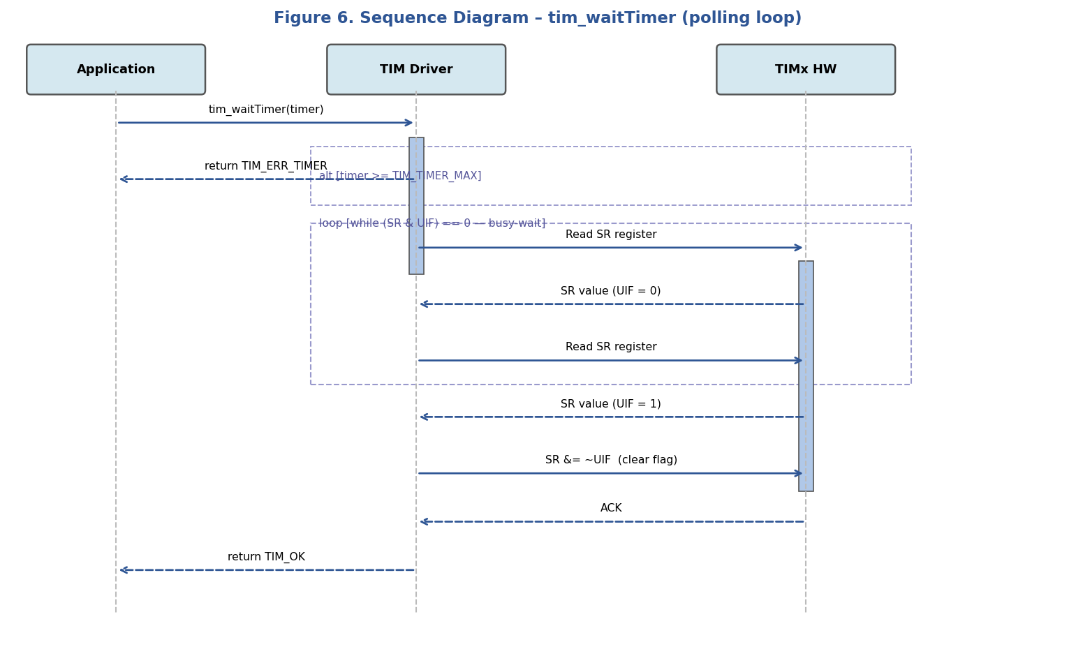
Figure 6. Sequence Diagram — tim_waitTimer (polling loop)

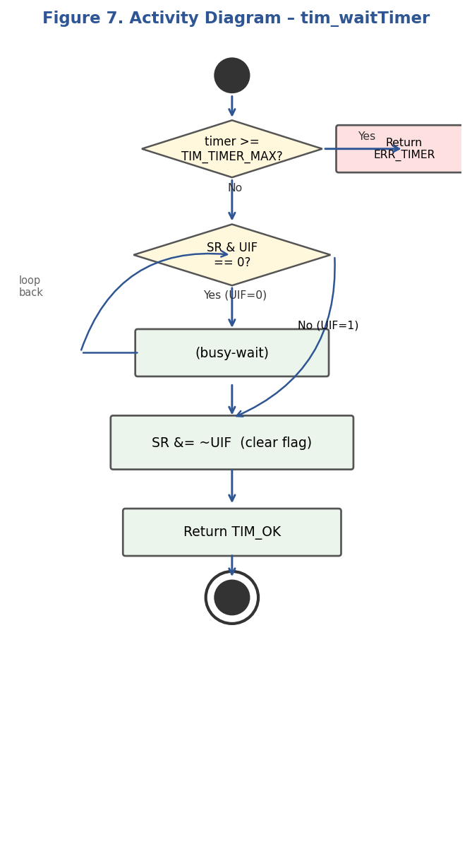
Figure 7. Activity Diagram — tim_waitTimer

Timer State Machine

The state diagram below describes the lifecycle of a single TIM peripheral from reset through initialization, period configuration, and optional PWM operation. Transitions labeled with dashed lines represent optional reverse paths (e.g., tim_disableTimer can return to the INITIALIZED state from RUNNING).

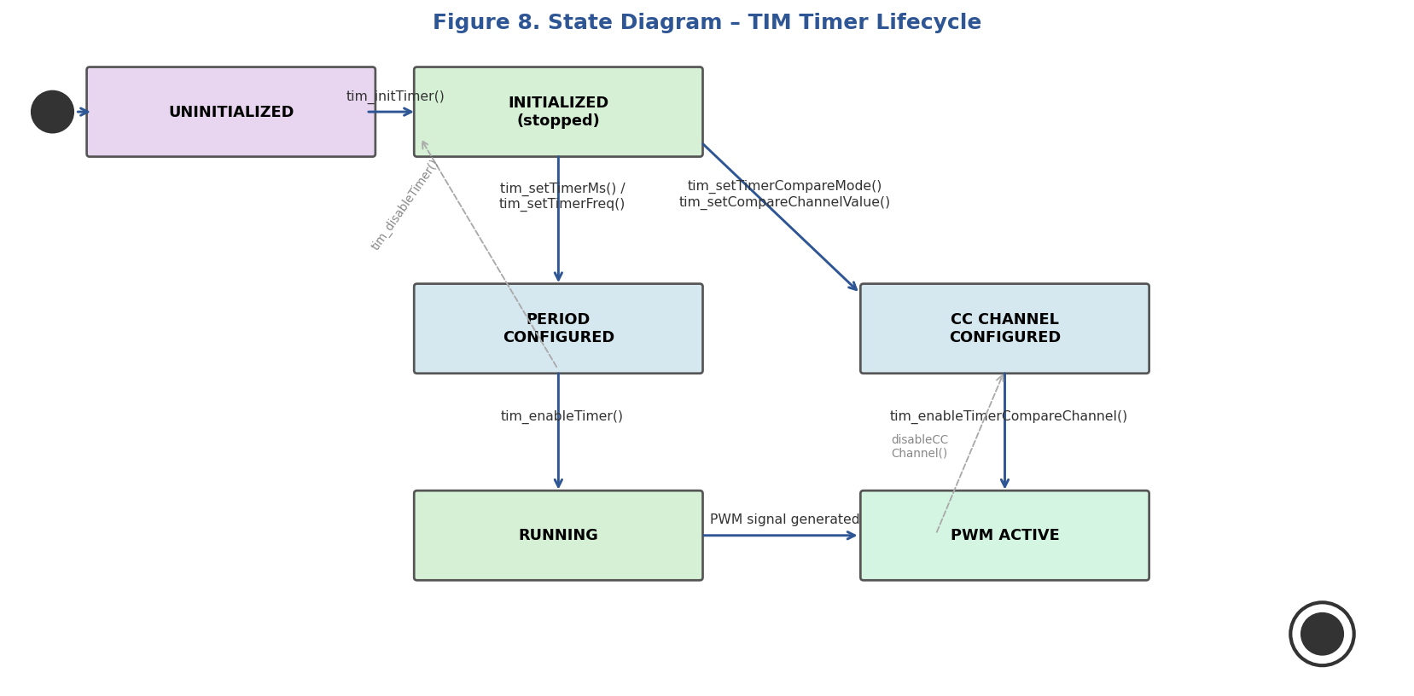
Figure 8. State Diagram — TIM Timer Lifecycle

  - TIM Driver

The TIM driver is implemented in two files: TIM_Driver.h (public declarations, hardware definitions, and type definitions) and TIM_Driver.c (function bodies and static internal data).

Internal Data Structures
- tim_peripherals[TIM_TIMER_MAX]: Static constant array of TIM_RegDef_t pointers mapping each TIM_Timer_t enum value to its hardware register base address. Enables O(1) timer lookup without switch/case in every function.
- tim_max_channels[TIM_TIMER_MAX]: Static constant array of uint8_t values specifying the maximum number of capture/compare channels per timer. Used by channel-parameter validation: TIM1/2–5 → 4, TIM9 → 2, TIM10/TIM11 → 1.

Internal Helper Functions
- tim_enableClock(timer): Routes APB1ENR or APB2ENR writes to the correct RCC register based on which APB bus the requested timer is connected to (APB1: TIM2–5; APB2: TIM1, TIM9–11).
- tim_writeCCR(pTIM, channel, value): Writes value to the CCRx register (CCR1–CCR4) for the specified channel using a switch statement on the channel enum.
- tim_writeOCMode(pTIM, channel, mode): Clears CCxS bits (forces output direction) and OC1M/OC2M/OC3M/OC4M fields in CCMR1 or CCMR2, then writes the requested mode and enables the OCxPE preload bit to prevent glitches during duty cycle updates.

PSC / ARR Calculation

The timer tick frequency and period are governed by: f_tick = f_clk / (PSC + 1) and T = (ARR + 1) / f_tick. Both tim_setTimerMs and tim_setTimerFreq compute counts = f_clk / target, then split it into PSC = counts / 65536 and ARR = counts / (PSC + 1) − 1. This guarantees ARR fits in a 16-bit register. The system clock constant TIM_SYSTEM_CLOCK_HZ is defined as 16000000UL (HSI default) and must be updated if PLL is configured.

PWM Configuration Flow

To generate a PWM signal on a timer channel, the caller must execute the following sequence: (1) tim_initTimer to enable the clock; (2) tim_setTimerFreq to set the PWM frequency; (3) tim_setTimerCompareMode with TIM_OC_MODE_PWM1 to configure the channel; (4) tim_setTimerCompareChannelValue with CCR = ARR × duty_cycle to set the duty; (5) tim_enableTimerCompareChannel to activate the output; (6) tim_enableTimer to start counting. The GPIO pin must be separately configured in alternate function mode via the GPIO driver before the PWM signal appears on the physical pin.

- Application Programming Interfaces

  - Data Types and Macros

Register-Map Structures

TIM_RegDef_t: Maps the memory layout of a single TIM peripheral's hardware registers. Fields are declared volatile to prevent compiler optimization of register accesses. The struct covers all registers from CR1 (offset 0x00) through DMAR (offset 0x4C) as defined in RM0383 §13.4.

Member | Type | Notes / Definition
CR1 | volatile uint32_t | Offset 0x00 — Counter enable (CEN bit 0), auto-reload preload (ARPE bit 7).
CR2 | volatile uint32_t | Offset 0x04 — Master mode selection and other control.
SMCR | volatile uint32_t | Offset 0x08 — Slave mode control register.
DIER | volatile uint32_t | Offset 0x0C — DMA/Interrupt enable register.
SR | volatile uint32_t | Offset 0x10 — Status register. UIF (bit 0) set on overflow.
EGR | volatile uint32_t | Offset 0x14 — Event generation register.
CCMR1 | volatile uint32_t | Offset 0x18 — Capture/compare mode for CH1 (bits 6:4) and CH2 (bits 14:12).
CCMR2 | volatile uint32_t | Offset 0x1C — Capture/compare mode for CH3 (bits 6:4) and CH4 (bits 14:12).
CCER | volatile uint32_t | Offset 0x20 — CC1E/CC2E/CC3E/CC4E enable bits at positions channel×4.
CNT | volatile uint32_t | Offset 0x24 — Current counter value.
PSC | volatile uint32_t | Offset 0x28 — Prescaler. f_tick = f_clk / (PSC + 1).
ARR | volatile uint32_t | Offset 0x2C — Auto-reload value. Timer overflows when CNT reaches ARR.
RCR | volatile uint32_t | Offset 0x30 — Repetition counter (TIM1 only).
CCR1–CCR4 | volatile uint32_t | Offsets 0x34–0x40 — Compare thresholds. duty = CCRx / (ARR+1) × 100%.
BDTR | volatile uint32_t | Offset 0x44 — Break and dead-time register (TIM1 only).
DCR | volatile uint32_t | Offset 0x48 — DMA control register.
DMAR | volatile uint32_t | Offset 0x4C — DMA address for full transfer.

RCC_TIM_RegDef_t: Maps a subset of the STM32F411RE RCC peripheral registers. Only APB1ENR (offset 0x40) and APB2ENR (offset 0x44) are used by this driver to enable timer peripheral clocks. The struct includes all intermediate fields to ensure correct address alignment.

Member | Type | Notes / Definition
CR | volatile uint32_t | Offset 0x00 — PLL and oscillator control.
PLLCFGR | volatile uint32_t | Offset 0x04 — PLL configuration.
CFGR | volatile uint32_t | Offset 0x08 — Clock mux and prescalers.
CIR | volatile uint32_t | Offset 0x0C — Clock interrupt register.
AHB1RSTR, AHB2RSTR | volatile uint32_t | Offsets 0x10–0x14 — AHB peripheral reset registers.
RESERVED0[2] | volatile uint32_t | Offsets 0x18–0x1C — Reserved; must not be accessed.
APB1RSTR, APB2RSTR | volatile uint32_t | Offsets 0x20–0x24 — APB peripheral reset registers.
RESERVED1[2] | volatile uint32_t | Offsets 0x28–0x2C — Reserved; must not be accessed.
AHB1ENR, AHB2ENR | volatile uint32_t | Offsets 0x30–0x34 — AHB clock enable registers.
RESERVED2[2] | volatile uint32_t | Offsets 0x38–0x3C — Reserved; must not be accessed.
APB1ENR | volatile uint32_t | Offset 0x40 — APB1 clock enable. Bits 0–3: TIM2/3/4/5EN.
APB2ENR | volatile uint32_t | Offset 0x44 — APB2 clock enable. Bit 0: TIM1EN; bits 16–18: TIM9/10/11EN.

Enumerations

TIM_Timer_t: Identifies each supported TIM peripheral. Values 0–7 index the tim_peripherals[] and tim_max_channels[] lookup tables. TIM_TIMER_MAX is a sentinel used for bounds validation only.

Enum | Value | Definition
TIM_TIMER_1 | 0 | APB2 — advanced timer. 4 channels, supports PWM with dead-time.
TIM_TIMER_2 | 1 | APB1 — general purpose. 32-bit counter and ARR. 4 channels.
TIM_TIMER_3 | 2 | APB1 — general purpose. 16-bit. 4 channels.
TIM_TIMER_4 | 3 | APB1 — general purpose. 16-bit. 4 channels.
TIM_TIMER_5 | 4 | APB1 — general purpose. 32-bit counter and ARR. 4 channels.
TIM_TIMER_9 | 5 | APB2 — general purpose. 16-bit. 2 channels.
TIM_TIMER_10 | 6 | APB2 — general purpose. 16-bit. 1 channel.
TIM_TIMER_11 | 7 | APB2 — general purpose. 16-bit. 1 channel.
TIM_TIMER_MAX | 8 | Sentinel — boundary validation only; not a valid timer.

TIM_Channel_t: Identifies a capture/compare channel within a timer. Valid channels per timer: TIM1/2–5 support CH1–CH4; TIM9 supports CH1–CH2; TIM10/TIM11 support CH1 only.

Enum | Value | Definition
TIM_CHANNEL_1 | 0 | Channel 1 — CCER bit 0, CCR1, CCMR1 bits 6:4.
TIM_CHANNEL_2 | 1 | Channel 2 — CCER bit 4, CCR2, CCMR1 bits 14:12.
TIM_CHANNEL_3 | 2 | Channel 3 — CCER bit 8, CCR3, CCMR2 bits 6:4.
TIM_CHANNEL_4 | 3 | Channel 4 — CCER bit 12, CCR4, CCMR2 bits 14:12.
TIM_CHANNEL_MAX | 4 | Sentinel — boundary validation only.

TIM_OC_Mode_t: Specifies the output compare mode for a channel. Values correspond directly to the OC1M/OC2M/OC3M/OC4M 3-bit field encoding in CCMR1/2 (RM0383 §13.4.7) and can be written to the register without conversion.

Enum | Value | Definition
TIM_OC_MODE_FROZEN | 0x0 | Output unchanged regardless of counter value.
TIM_OC_MODE_ACTIVE_ON_MATCH | 0x1 | Output set active when CNT == CCR.
TIM_OC_MODE_INACTIVE_ON_MATCH | 0x2 | Output set inactive when CNT == CCR.
TIM_OC_MODE_TOGGLE | 0x3 | Output toggles when CNT == CCR.
TIM_OC_MODE_FORCE_INACTIVE | 0x4 | Output forced low regardless of counter.
TIM_OC_MODE_FORCE_ACTIVE | 0x5 | Output forced high regardless of counter.
TIM_OC_MODE_PWM1 | 0x6 | PWM mode 1 — active while CNT < CCR (recommended for PWM output).
TIM_OC_MODE_PWM2 | 0x7 | PWM mode 2 — inactive while CNT < CCR.
TIM_OC_MODE_MAX | 0x8 | Sentinel — boundary validation only.

Preprocessor Macros

Macro | Value | Definition
APB1PERIPH_BASE | PERIPH_BASE + 0x00000000UL | Base address of the APB1 peripheral bus.
TIM2_BASE | APB1PERIPH_BASE + 0x0000UL | Base address of TIM2 registers (0x40000000).
TIM3_BASE | APB1PERIPH_BASE + 0x0400UL | Base address of TIM3 registers (0x40000400).
TIM4_BASE | APB1PERIPH_BASE + 0x0800UL | Base address of TIM4 registers (0x40000800).
TIM5_BASE | APB1PERIPH_BASE + 0x0C00UL | Base address of TIM5 registers (0x40000C00).
APB2PERIPH_BASE | PERIPH_BASE + 0x00010000UL | Base address of the APB2 peripheral bus.
TIM1_BASE | APB2PERIPH_BASE + 0x0000UL | Base address of TIM1 registers (0x40010000).
TIM9_BASE | APB2PERIPH_BASE + 0x4000UL | Base address of TIM9 registers (0x40014000).
TIM10_BASE | APB2PERIPH_BASE + 0x4400UL | Base address of TIM10 registers (0x40014400).
TIM11_BASE | APB2PERIPH_BASE + 0x4800UL | Base address of TIM11 registers (0x40014800).
TIM1 … TIM11 | (TIM_RegDef_t *) TIMx_BASE | Typed pointer macros for direct register access.
RCC_TIM | (RCC_TIM_RegDef_t *) RCC_BASE | Typed pointer for RCC register access (APB1ENR, APB2ENR).
RCC_APB1ENR_TIM2EN | (1U << 0) | Bit mask to enable TIM2 clock in RCC->APB1ENR.
RCC_APB1ENR_TIM3EN | (1U << 1) | Bit mask to enable TIM3 clock in RCC->APB1ENR.
RCC_APB1ENR_TIM4EN | (1U << 2) | Bit mask to enable TIM4 clock in RCC->APB1ENR.
RCC_APB1ENR_TIM5EN | (1U << 3) | Bit mask to enable TIM5 clock in RCC->APB1ENR.
RCC_APB2ENR_TIM1EN | (1U << 0) | Bit mask to enable TIM1 clock in RCC->APB2ENR.
RCC_APB2ENR_TIM9EN | (1U << 16) | Bit mask to enable TIM9 clock in RCC->APB2ENR.
RCC_APB2ENR_TIM10EN | (1U << 17) | Bit mask to enable TIM10 clock in RCC->APB2ENR.
RCC_APB2ENR_TIM11EN | (1U << 18) | Bit mask to enable TIM11 clock in RCC->APB2ENR.
TIM_CR1_CEN | (1U << 0) | Counter Enable bit in TIMx_CR1.
TIM_CR1_ARPE | (1U << 7) | Auto-Reload Preload Enable bit in TIMx_CR1.
TIM_SR_UIF | (1U << 0) | Update Interrupt Flag in TIMx_SR. Set on overflow; cleared by software.
TIM_SYSTEM_CLOCK_HZ | 16000000UL | System clock frequency assumption (HSI default). Update if PLL is used.

  - Error Codes

All public TIM API functions (except tim_init, which returns void) return a TIM_Status_t value. Error codes are listed below.

Code | Value | Definition
TIM_OK | 0 | Operation completed successfully.
TIM_ERR_TIMER | -1 | The timer parameter is invalid (>= TIM_TIMER_MAX).
TIM_ERR_CHANNEL | -2 | The channel parameter is invalid for the specified timer (>= tim_max_channels[timer]).
TIM_ERR_MODE | -3 | The mode parameter is invalid (>= TIM_OC_MODE_MAX).
TIM_ERR_PARAM | -4 | A numeric parameter is invalid (e.g., ms == 0 or freq_hz == 0 or freq_hz > TIM_SYSTEM_CLOCK_HZ).

  - Function Definitions

Function Name | tim_init
Syntax | void tim_init(void)
Parameters (in) | None
Parameters (inout) | None
Parameters (out) | None
Return value | void
Description | Enables peripheral clocks for all eight supported TIM peripherals and resets CR1, PSC, ARR, CNT, CCER, and SR to default values. Iterates using TIM_Timer_t from TIM_TIMER_1 to TIM_TIMER_MAX-1, calling tim_enableClock() for each.
Constraints | No parameter validation. Must be called before any other TIM driver function. Resets all timers simultaneously — do not call if any timer is in use.
Available via | TIM_Driver.h

Function Name | tim_initTimer
Syntax | TIM_Status_t tim_initTimer(TIM_Timer_t timer)
Parameters (in) | timer — TIM_Timer_t: selects the timer to initialize.
Parameters (inout) | None
Parameters (out) | None
Return value | TIM_Status_t — TIM_OK on success. TIM_ERR_TIMER if timer >= TIM_TIMER_MAX.
Description | Enables the peripheral clock for a single timer via tim_enableClock(), then resets CR1, PSC, ARR, CNT, CCER, and SR to default values. Preferred over tim_init when only a specific timer needs initialization.
Constraints | Does not start the counter. Caller must call tim_setTimerMs or tim_setTimerFreq before tim_enableTimer.
Available via | TIM_Driver.h

Function Name | tim_setTimerMs
Syntax | TIM_Status_t tim_setTimerMs(TIM_Timer_t timer, uint32_t ms)
Parameters (in) | timer — TIM_Timer_t: target timer. ms — uint32_t: desired period in milliseconds (must be > 0).
Parameters (inout) | None
Parameters (out) | None
Return value | TIM_Status_t — TIM_OK on success. TIM_ERR_TIMER if invalid timer. TIM_ERR_PARAM if ms == 0.
Description | Calculates PSC and ARR to produce the requested interval: counts = (TIM_SYSTEM_CLOCK_HZ / 1000) * ms; PSC = counts / 65536; ARR = counts / (PSC + 1) - 1. Writes PSC, ARR, resets CNT to 0, and clears UIF.
Constraints | TIM_SYSTEM_CLOCK_HZ must match the actual system clock. Does not start the timer — caller must call tim_enableTimer after.
Available via | TIM_Driver.h

Function Name | tim_setTimerFreq
Syntax | TIM_Status_t tim_setTimerFreq(TIM_Timer_t timer, uint32_t freq_hz)
Parameters (in) | timer — TIM_Timer_t: target timer. freq_hz — uint32_t: desired frequency in Hz (must be > 0 and <= TIM_SYSTEM_CLOCK_HZ).
Parameters (inout) | None
Parameters (out) | None
Return value | TIM_Status_t — TIM_OK on success. TIM_ERR_TIMER or TIM_ERR_PARAM if inputs are invalid.
Description | Calculates PSC and ARR to produce the requested frequency: counts = TIM_SYSTEM_CLOCK_HZ / freq_hz; PSC = counts / 65536; ARR = counts / (PSC + 1) - 1. Used primarily for PWM frequency configuration.
Constraints | Same constraints as tim_setTimerMs regarding clock accuracy and timer start.
Available via | TIM_Driver.h

Function Name | tim_enableTimer
Syntax | TIM_Status_t tim_enableTimer(TIM_Timer_t timer)
Parameters (in) | timer — TIM_Timer_t: timer to start.
Parameters (inout) | None
Parameters (out) | None
Return value | TIM_Status_t — TIM_OK on success. TIM_ERR_TIMER if invalid.
Description | Sets TIM_CR1_CEN (bit 0) and TIM_CR1_ARPE (bit 7) in TIMx_CR1, starting the counter and enabling auto-reload preload.
Constraints | PSC and ARR must be configured before calling. Calling without prior configuration produces unpredictable timing.
Available via | TIM_Driver.h

Function Name | tim_disableTimer
Syntax | TIM_Status_t tim_disableTimer(TIM_Timer_t timer)
Parameters (in) | timer — TIM_Timer_t: timer to stop.
Parameters (inout) | None
Parameters (out) | None
Return value | TIM_Status_t — TIM_OK on success. TIM_ERR_TIMER if invalid.
Description | Clears the CEN bit in TIMx_CR1, stopping the counter. The CNT value is preserved; the counter resumes from its current value if tim_enableTimer is called again.
Constraints | Does not disable active capture/compare channels. Caller should disable channels explicitly if needed.
Available via | TIM_Driver.h

Function Name | tim_waitTimer
Syntax | TIM_Status_t tim_waitTimer(TIM_Timer_t timer)
Parameters (in) | timer — TIM_Timer_t: timer to wait on.
Parameters (inout) | None
Parameters (out) | None
Return value | TIM_Status_t — TIM_OK on success. TIM_ERR_TIMER if invalid.
Description | Busy-waits by polling TIMx_SR bit 0 (UIF) until set by hardware on counter overflow, then clears the flag by writing 0 to UIF (rc_w0 access type).
Constraints | Blocking — suspends CPU until overflow. The timer must be running. If the timer is not enabled, this function loops indefinitely. Not suitable for interrupt-driven or RTOS contexts.
Available via | TIM_Driver.h

Function Name | tim_setTimerCompareChannelValue
Syntax | TIM_Status_t tim_setTimerCompareChannelValue(TIM_Timer_t timer, TIM_Channel_t channel, uint32_t value)
Parameters (in) | timer — TIM_Timer_t: target timer. channel — TIM_Channel_t: target channel. value — uint32_t: compare threshold. For PWM: value = ARR * duty_cycle_fraction.
Parameters (inout) | None
Parameters (out) | None
Return value | TIM_Status_t — TIM_OK, TIM_ERR_TIMER, or TIM_ERR_CHANNEL.
Description | Writes value to the CCRx register (CCR1–CCR4) for the specified channel via the tim_writeCCR() helper. In PWM mode, the duty cycle is value / (ARR + 1) × 100%.
Constraints | Channel must be valid for the selected timer (tim_max_channels validation). Value should be <= ARR for meaningful PWM output.
Available via | TIM_Driver.h

Function Name | tim_setTimerCompareMode
Syntax | TIM_Status_t tim_setTimerCompareMode(TIM_Timer_t timer, TIM_Channel_t channel, TIM_OC_Mode_t mode)
Parameters (in) | timer — TIM_Timer_t: target timer. channel — TIM_Channel_t: target channel. mode — TIM_OC_Mode_t: desired output compare mode.
Parameters (inout) | None
Parameters (out) | None
Return value | TIM_Status_t — TIM_OK, TIM_ERR_TIMER, TIM_ERR_CHANNEL, or TIM_ERR_MODE.
Description | Configures CCMR1 or CCMR2 for the specified channel via tim_writeOCMode(). Clears CCxS bits (output direction), sets OC1M/OC2M/OC3M/OC4M to the requested mode, and enables OCxPE (preload) to prevent glitches.
Constraints | Must be called before tim_enableTimerCompareChannel. Changes take effect at the next update event if the timer is already running.
Available via | TIM_Driver.h

Function Name | tim_enableTimerCompareChannel
Syntax | TIM_Status_t tim_enableTimerCompareChannel(TIM_Timer_t timer, TIM_Channel_t channel)
Parameters (in) | timer — TIM_Timer_t: target timer. channel — TIM_Channel_t: channel to enable.
Parameters (inout) | None
Parameters (out) | None
Return value | TIM_Status_t — TIM_OK, TIM_ERR_TIMER, or TIM_ERR_CHANNEL.
Description | Sets the CCxE bit in TIMx_CCER at position channel×4, activating the channel output. For PWM, the physical signal appears on the GPIO pin only if the pin is also configured in alternate function mode.
Constraints | The GPIO pin must be configured in alternate function mode before the PWM signal appears on hardware.
Available via | TIM_Driver.h

Function Name | tim_disableTimerCompareChannel
Syntax | TIM_Status_t tim_disableTimerCompareChannel(TIM_Timer_t timer, TIM_Channel_t channel)
Parameters (in) | timer — TIM_Timer_t: target timer. channel — TIM_Channel_t: channel to disable.
Parameters (inout) | None
Parameters (out) | None
Return value | TIM_Status_t — TIM_OK, TIM_ERR_TIMER, or TIM_ERR_CHANNEL.
Description | Clears the CCxE bit in TIMx_CCER at position channel×4, deactivating the channel output. The timer continues running; only the compare output is suppressed.
Constraints | Does not stop the timer. Call tim_disableTimer separately if the counter itself must stop.
Available via | TIM_Driver.h

  - Internal Function Definitions

Function Name | tim_enableClock (internal)
Syntax | static void tim_enableClock(TIM_Timer_t timer)
Parameters (in) | timer — TIM_Timer_t: timer whose clock will be enabled.
Parameters (inout) | None
Parameters (out) | None
Return value | void
Description | Routes the clock enable write to RCC->APB1ENR for TIM2–TIM5, or to RCC->APB2ENR for TIM1, TIM9, TIM10, and TIM11, using a switch statement. Called by both tim_init and tim_initTimer.
Constraints | Not visible externally (static). No input validation — caller must ensure timer < TIM_TIMER_MAX.
Available via | TIM_Driver.c (internal only)

Function Name | tim_writeCCR (internal)
Syntax | static void tim_writeCCR(TIM_RegDef_t *pTIM, TIM_Channel_t channel, uint32_t value)
Parameters (in) | pTIM — pointer to TIM registers. channel — TIM_Channel_t: target channel. value — uint32_t: compare threshold to write.
Parameters (inout) | None
Parameters (out) | None
Return value | void
Description | Writes value to CCR1, CCR2, CCR3, or CCR4 based on channel, via a switch statement. Called by tim_setTimerCompareChannelValue after validation.
Constraints | Not visible externally (static). pTIM must be a valid non-null pointer. No bounds check on value.
Available via | TIM_Driver.c (internal only)

Function Name | tim_writeOCMode (internal)
Syntax | static void tim_writeOCMode(TIM_RegDef_t *pTIM, TIM_Channel_t channel, TIM_OC_Mode_t mode)
Parameters (in) | pTIM — pointer to TIM registers. channel — TIM_Channel_t: target channel. mode — TIM_OC_Mode_t: output compare mode to configure.
Parameters (inout) | None
Parameters (out) | None
Return value | void
Description | Performs read-modify-write on CCMR1 (CH1/CH2) or CCMR2 (CH3/CH4). Clears CCxS bits (output direction) and OC1M/OC2M/OC3M/OC4M field using mask 0x73, then writes mode at the correct shift (TIM_CCMR_OC1M_SHIFT=4, TIM_CCMR_OC2M_SHIFT=12). Enables OCxPE preload bit. Called by tim_setTimerCompareMode after validation.
Constraints | Not visible externally (static). pTIM must be a valid non-null pointer.
Available via | TIM_Driver.c (internal only)

- Future Enhancements

The following enhancements may be considered for future revisions of the TIM driver:
- Interrupt-driven operation: Add support for enabling the UIF interrupt in DIER and registering a callback, eliminating the busy-wait in tim_waitTimer for RTOS-aware applications.
- Input capture mode: Extend CCMR1/2 configuration to support input capture for frequency/pulse measurement applications.
- One-pulse mode (OPM): Add support for TIM_CR1_OPM to generate a single timed pulse without software intervention.
- 32-bit timer support annotation: Explicitly document and validate the larger ARR range available on TIM2 and TIM5 (32-bit) to allow longer intervals without increasing PSC.
- tim_setTimerFreq accuracy improvement: Add rounding logic to minimize PSC/ARR quantization error for frequencies that do not divide evenly into TIM_SYSTEM_CLOCK_HZ.
- Dynamic clock source: Replace the compile-time TIM_SYSTEM_CLOCK_HZ constant with a runtime SystemCoreClock variable to automatically adapt to PLL configuration changes.
- DMA burst mode: Support the DCR and DMAR registers for high-speed compare value updates without CPU intervention.

